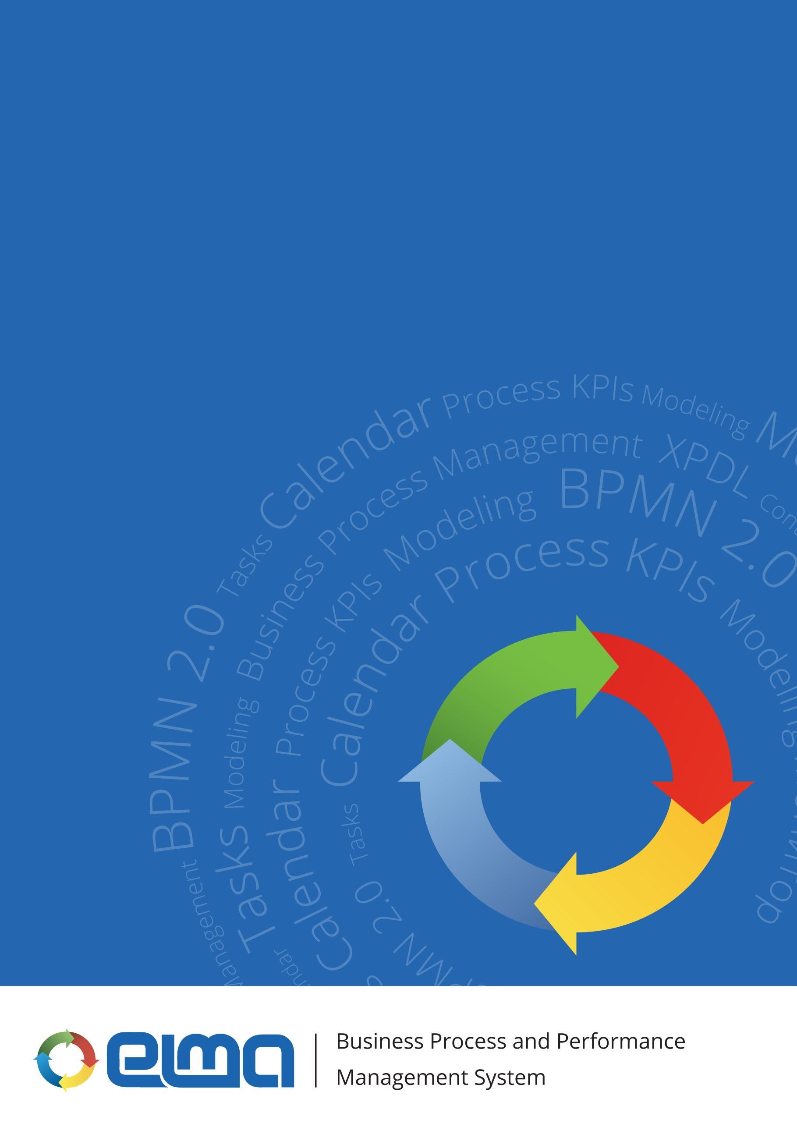

ELMA object model in terms of organizational structure

Contents
1
ELMA object model in terms of organizational structure 3
1.1 Specifics of creating objects 4
1.1.1 Organizational structure model 4
1.1.2 Organizational structure item 5

ELMA object model in terms of organizational structure
For the functioning of the organizational structure, the following object model has been developed in ELMA (fig. 1). The scheme also shows the connection between the organizational structure objects with the user objects (green).

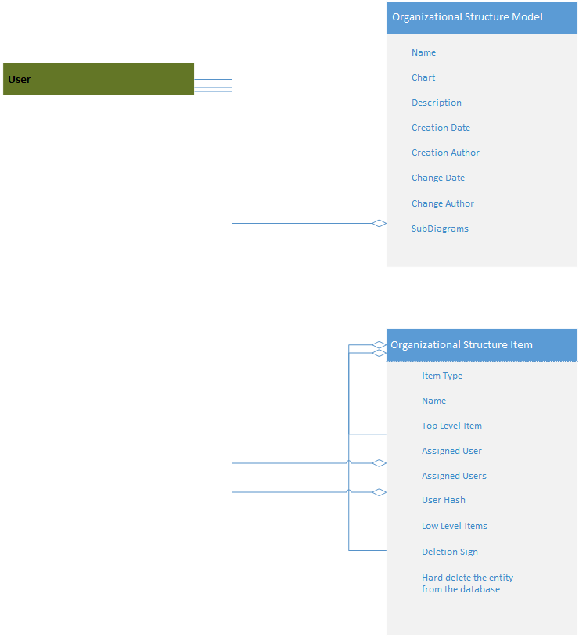
Fig. 1. ELMA object model in terms of organizational structure

For the organizational structure to function, the following objects has been implemented:

No. | Name | Purpose
1 | Organizational structure model | Information on all the organizational structure versions
2 | Organizational structure item | Information on all the organizational structure items

Specifics of creating objects

Organizational structure model
This object is created and edited in ELMA Designer on the Organizational Structure tab.

No. | Displayed Name | Property Name | Value type, filling in rules | Field purpose
1 | Name | Name | String, required | Organizational structure version number
2 | Chart | Diagram | Organizational structure chart, optional | Organizational structure chart serialized view
3 | Description | Description | String, optional | Organizational structure description
4 | Creation Date | CreationDate | Date/Time, filled in automatically | Organizational structure creation date and time
5 | Creation Author | CreationAuthor | User (object), filled in automatically | User, who created the organizational structure model
6 | Change Date | ChangeDate | Date/Time, filled in automatically | Date and time of the last organizational structure change
7 | Change Author | ChangeAuthor | User (object), filled in automatically | User, who made the last change to the organizational structure
8 | SubDiagrams | SubDiagrams | Nested structure charts | List of nested structures

Organizational structure item
This object is created and edited in ELMA Designer on the Organizational Structure tab.

No. | Displayed Name | Property Name | Value type, filling in rules | Field purpose
1 | Item type | ItemType | Organizational structure item type (enumeration), required.  Allowed values:  - 0 – Department,  - 1 – Job position,  - 2 – Employee group,  - 3 – Nested structure | Organizational structure item type
2 | Name | Name | String, required | Item name
3 | Top level item | ParentItem | Organizational structure item (object), optional | Organizational structure item, which is a top level item
4 | Assigned user | User | User (object), optional | User, assigned to the organizational structure item of the Job Position type
5 | Assigned users | Users | <User (object)> (N-N) list, optional | Users, assigned to the organizational structure item of the Employee Group type
6 | UserHash | UserHash | String, optional | Hash for tracking changes in the User collection
7 | Low level items | SubItems | <Organizational structure items (object)> (1-N) list, optional | List of organizational structure items, which are low level items (child items of the current item)
8 | Deletion Sign | IsDeleted | Yes/No, optional | Used for soft deleting. If Yes is selected, the object will be marked as deleted
9 | Hard delete the entity from the database | HardDeleted | Yes/No, optional | If Yes is selected, the entry will be deleted upon the next saving to the database

