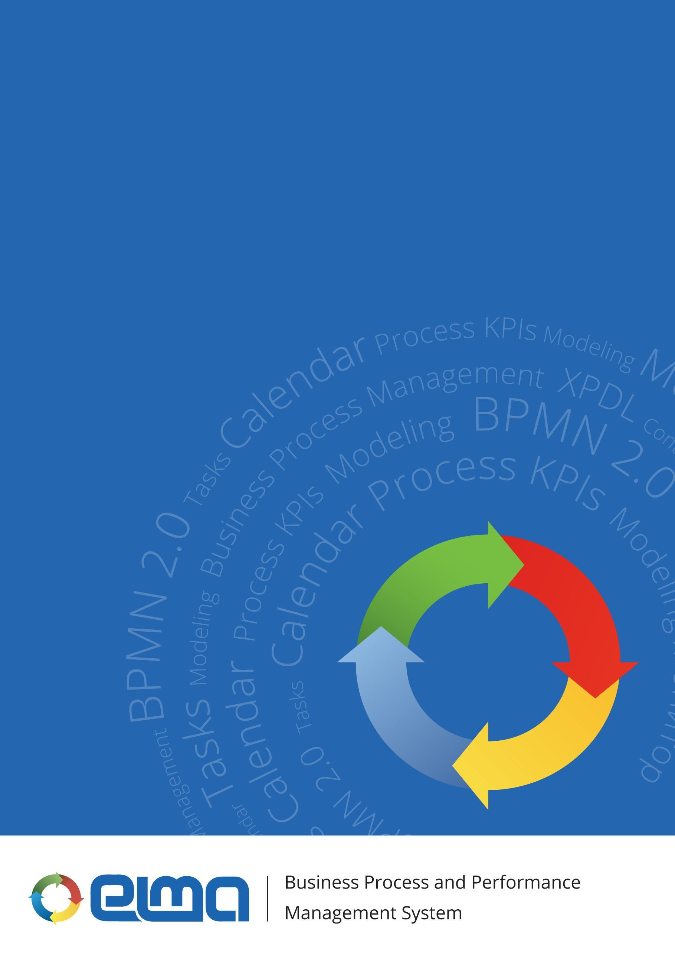
ELMA object model in terms of users

Contents

ELMA object model in terms of users 3
1.1 Specifics of creating objects 5
1.1.1 User group 5
1.1.2 Substitution 6
1.1.3 Set of users 8
1.1.4 User absence 8
1.1.5 User 9
1.1.6 User substitution rule 11
1.1.7 User certificate 12
1.1.8 User token 12

ELMA object model in terms of users

To work with users in ELMA, the following object model has been developed (fig. 1). The scheme also shows the connection between the user objects and the organizational structure objects (green).

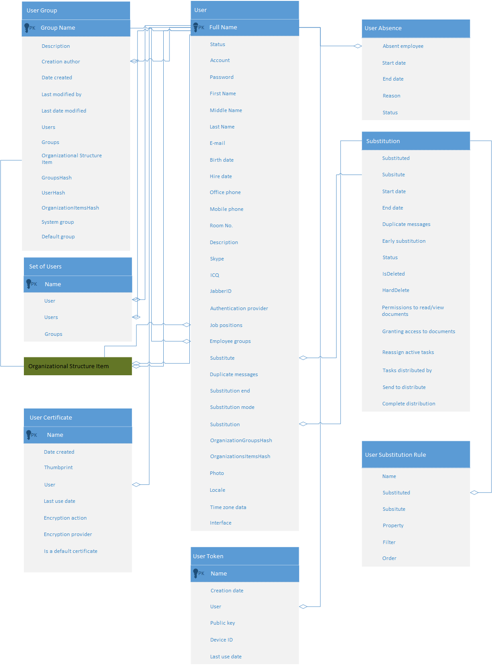
Fig. 1. Scheme of ELMA object model in terms of users

The following objects have been implemented for working with users:

No. | Name | Object purpose
1 | User group | Data on user groups in the system
2 | Substitution | Data on configured substitutions
3 | Set of users | Data on created sets of users
4 | User absence | Data on absent users
5 | User | Data on system users
6 | User substitution rule | Data on substitution rules in the system
7 | User certificate | Data on digital signature certificates, bound to users
8 | User token | Data on tokens, bound to users

Specifics of creating objects

User group
This object is created and edited in Web Application in Administration – Users – Groups.

No. | Displayed Name | Property Name | Value type, filling in rules | Field purpose
1 | Group name | Name | String, required field | User group name
2 | Description | Description | String, optional field | Additional information about the user group
3 | Creation author | CreationAuthor | User (object), filled in automatically | User, who created the user group
4 | Date created | CreationDate | Date/Time, filled in automatically | Date and time when the user group was created
5 | Last modified by | ChangeAuthor | User (object), filled in automatically | User, who made the last change to the user group
6 | Last date modified | ChangeDate | Date/Time, filled in automatically | Date and time of the last change made to the user group
7 | Users | Users | <User (object)> (N-N) list, optional field | List of users included in this user group
8 | Groups | Groups | <User group (object)> (N-N) list, optional field | List of user groups, included in this user group
9 | Organizational structure item | OrganizationItems | <Organizational structure item (object)> (N-N) list, optional field | List of organizational structure items, included in this user group
10 | GroupsHash | GroupsHash | String, optional field | Hash for tracking changes in the Groups collection
11 | UserHash | UserHash | String, optional field | Hash for tracking changes in the User collection
12 | OrganizationItemsHash | OrganizationItemsHash | String, optional field | Hash for tracking changes in the OrganizationItems collection
13 | System group | IsSystem | Yes/No, filled in by the platform developer | Defines whether the user group is a system group. If Yes, then users will not be able to change it in Web Application
14 | Default group | AddToNewUser | Yes/No, required field | Defines whether the user group is a default group. If Yes, then all the new users will be included in this group

Substitution
This object is created and edited in Web Application in Administration – Users – Substitutions.

No. | Displayed Name | Property Name | Value type, filling in rules | Field purpose
1 | Substituted | SourseUser | User (object), required field | User, who is being substituted
2 | Substitute | TargetUser | User (object), required field | User, who substitutes
3 | Substitution mode |  | Substitution mode in tasks (Enumeration).  Allowed values:  0 – Full;  1 – Co-executor. | Substitution mode
4 | Start date | StartDate | Date/Time, required field | Substitution start date
5 | End date | EndDate | Date/Time, required field | Substitution end date
6 | Duplicate messages | DuplicateMessage | Yes/No, optional field | Defines whether to duplicate messages for the substitute user. If Yes, then system messages will be sent to the substituted user and to the substitute user
7 | Early substitution | PreReplace | Integer, required field | Number of business days before the substitution start date, when you need the system to start the substitution (reassign tasks, inform users)
8 | Status | Status | Substitution status (Enumeration), required field.  Allowed values:  0 – Active,  1 – Deleted | Substitution status
9 | IsDeleted | IsDeleted | Yes/No | Used for soft deleting. If Yes, then the object will be marked as deleted.
10 | HardDelete | HardDelete | Yes/No | If Yes, then the entry will be deleted at the next saving to the database
11 | Permissions to read/view documents | DocumentPermissions | Yes/No, required field | Defines the possibility to automatically grant permissions to documents attached to tasks to the substitute user. If Yes, when reassigning tasks with attached documents, the substitute user will be automatically granted View/Load permissions to the document.
12 | Granting access to documents | ManageDocumentPermissions | Yes/No, required field | Defines the possibility to automatically grant the substitute user Manage Access permissions to the documents attached to tasks. If Yes, then when reassigning a task with a document, the substitute user will be automatically granted Manage Access permissions to the document.
13 | Reassign active tasks | ReAssignActiveTasks | Yes/No, required field | Defines the possibility to reassign active tasks of the substituted user. If Yes, then active tasks of the substituted user will be reassigned to the substitute user.
14 | Tasks distributed by | TasksDistributer | User (object), optional field | User who will receive a task to reassign active tasks of the substituted user.  Note: It is recommended to select the substituted user.
15 | Send to distribute | ReAssignStartDays | Integer, required field | Number of days before the substitution start date when the task to reassign active tasks of the substituted user will be sent
16 | Complete distribution | ReAssignFinishDays | Integer, required field | Number of days to reassign active tasks of the substituted user

Set of users
This object is created and edited in Web Application when creating activities (message, task, calendar event, etc.).

No. | Displayed Name | Property Name | Value type, filling in rules | Field purpose
1 | User | Owner | User (object), required field | User, who created the set of users
2 | Name | Name | String, required field | Name of the set of users
3 | Users | Users | <User (object)> (N-N) list, optional field | List of users included in this set of users
4 | Groups | Groups | <User group (object)> (N-N) list, optional field | List of groups included in this set of users

User absence
This object is created and edited in Web Application in Administration – Users – Absence Schedule.

No. | Displayed Name | Property Name | Value type, filling in rules | Field purpose
1 | Absent employee | User | User (object), required field | User, for whom absence is created
2 | Start date | StartDate | Date/Time, required field | Absence start date and time
3 | End date | EndDate | Date/Time, required field | Absence end date and time
4 | Reason | Description | String, required field | Reason of the user absence
5 | Status | Status | Absence status (enumeration).  Allowed values:  0 – Active,  1 – Canceled | Absence status

User
This object is created and edited in Web Application in Administration – Users – Users.

No. | Displayed Name | Property Name | Value type, filling in rules | Field purpose
1 | Account | UserName | String, required field | User login for signing in to the system
2 | Password | Password | String, optional field | User password for signing in to the system
3 | Last Name | LastName | String, required field | System user last name
6 | First Name | FirstName | String, required field | System user first name
4 | Middle Name | MiddleName | String, optional field | System user middle name
5 | Full Name | FullName | String, filled in automatically based on the Last Name, First Name and Middle Name fields | Key field (object instance name)
7 | Status | Status | Account stats (Enumeration).  Allowed values:  0 – Active,  1 – Locked,  10 – Not confirmed,  100 - System | User account status
8 | E-Mail | EMail | String, optional field | User e-mail
9 | Birth Date | BirthDate | Date/Time, optional field | User birthday
10 | Hire date | EmployDate | Date/Time, optional field | Date of hiring. By default, the user creation date is selected
11 | Office phone | WorkPhone | String, optional field | User office phone
12 | Mobile phone | MobilePhone | String, optional field | User mobile phone
13 | Room No. | RoomNumber | String, optional field | Room number in an office building
14 | Description | Description | String, optional field | Additional information about the user
15 | Skype | Skype | String, optional field | User Skype
16 | ICQ | ICQ | String, optional field | User ICQ
17 | Jabber ID | JabberID | String, optional field | User JabberID
18 | Authentication provider | AuthProviderGuid | Unique identifier (GUID), optional field | User authentication method. If null, the standard authentication is used, if non-null LDAP/AD is used
19 | Job positions | OrganizationItems | <Organizational structure item (object)> (1-N) list), optional field | List of organizational structure items of the Job Position type, to which this user is assigned
20 | Employee group | OrganizationGroups | <Organizational structure item (object)> (N-N) list, optional field | List of organizational structure items of the Employee Group type, which include the user
21 | Substitute | ReplacementUser | User (object), filled in automatically when creating a Substitution object | User, who is the substitute when creating a substitution for this user
22 | Duplicate messages | DuplicateMessage | Yes/No, filled in automatically when creating a Substitution object | Defines whether to duplicate messages for the substitute user. If Yes, then system messages will be sent to the substituted user and to the substitute user
23 | Substitution end | EndReplacement | Date/Time, filled in automatically when creating a Substitution object | End date of the current user substitution
24 | Substitution mode | ReplacementMode | Substitution mode (Enumeration).  Allowed values:  - 0 – None,  - 1 – Manual substitution,  - 2 – Automatic substitution | Substitution mode
25 | Substitution | Replacement | Substitution (object), optional field | Current substitution
26 | OrganizationGroupsHash | OrganizationGroupsHash | String, optional field | Hash for tracking changes in the OrganizationGroups collection
27 | OrganizationItemsHash | OrganizationItemsHash | String, optional field | Hash for tracking changes in the OrganizationItems collection
28 | Photo | Photo | File, optional field | User photo, the file size limit is 1000MB. It will be displayed in the system interface
29 | Locale | Lang | String, optional field | System language
30 | E-mail format | EmailFormat | String, optional field | Regular expression for setting an e-mail address format
31 | Installed system locale | IsSystemLocal | Yes/No, optional field | Use the system language
32 | Time zone data | TimeZoneDate | String, optional field | Serialized time zone
33 | Interface | WorkPlace | Interface (object), required field | User interface type, which will be used for this user by default

User substitution rule
This object is created and edited in Administration – Users – Substitutions.

No. | Displayed Name | Property Name | Value type, filling in rules | Field purpose
1 | Name | Name | String, required field | Substitution rule name
2 | Substitution | Replacement | Substitution (object), required field | Existing substitution, for which this substitution rule is used
3 | Substitute user | TargetUser | User (object), required field | Substitute user
4 | Property | PropertyUid | Unique identifier (GUID), optional field | List of task types specifying the user property, which defines the user role in the task, for which the rule is created
5 | Filter | Filter | XML-serializable object, optional field | Serializable object in the XML format
6 | Order | Order | Integer (32 bit), optional field | Stage number in the rule application order

User certificate
This object is not created or edited in Web Application.

No. | Displayed Name | Property Name | Value type, filling in rules | Field purpose
1 | Name | Name | String, required field | User certificate name
2 | Date created | CreationDate | Date/Time, filled in automatically | Certificate creation date and time
3 | Thumbprint | Thumbrint | String, required field | Thumbprint
4 | User | User | User (object), required field | User who owns the certificate
5 | Last use date | LastTouchDate | Date/Time, filled in automatically | Date and time of the last use of the certificate
6 | Encryption action | CryptoActionGuid | Unique identifier (GUID), required field | Action, which can be executed with this user certificate
7 | Encryption provider | CryptoProviderGuid | Unique identifier (GUID), required field | Encryption provider, to which the user certificate belongs
8 | Is a default certificate | IsDefault | Yes/No, optional field | Defines whether this user certificate is a default certificate

User token
This object is not created or edited in Web Application.

№ | No. | Displayed Name | Property Name | Value type, filling in rules
1 | Name | Name | String, required field | Token name
2 | Date created | CreationDate | Date/Time, filled in automatically | User token creation date and time
3 | User | User | User (object), required field | User, who owns this token
4 | Public key | PublicKey | String, required field | Token public key
5 | Device ID | Deviceld | String, required field | Device ID
6 | Last use date | LastLogonDate | Date/Time, filled in automatically | Token last use date and time

